Strategic Portfolio Analysis & Operational Optimization

Summary
Hero FinCorp currently manages a massive and diverse portfolio of 70,000 unique customers and over 495,000 individual transactions. At its current critical scale, the portfolio holds a total expected revenue of $251.38 Billion. This analysis moves beyond standard reporting to implement a Predictive Risk Model designed to secure $24.91 Billion in projected interest by isolating the top 12% of high-risk customers and protecting our top 25% VIP segment.

The Methodology :
We utilized advanced data science techniques to segment the portfolio based on behavioral consistency rather than just credit scores. By measuring the "Irregularity Score" of payments and the "Penalty Burden" on individual accounts, we shifted the focus from reactive collection to proactive risk management.

The Result :
Our analysis successfully identified three high-impact areas for immediate action:
- Risk Identification: We have isolated the top 12% of "High-Risk" customers who exhibit erratic payment patterns. These individuals represent the most likely candidates for default in the next 60–90 days.
- Operational Optimization: Data revealed a 200% variance in loan processing times across branches. Standardizing these workflows could unlock significant capital and improve customer satisfaction.
- Revenue Protection: We identified a Top 25% "VIP Segment" responsible for the highest share of stable interest income. We have developed a retention strategy to protect these high-value assets from competitors.

Pillar 1: Minimizing Loan Defaults 🔴
Goal: Transition from reactive collections to proactive behavioral intervention.
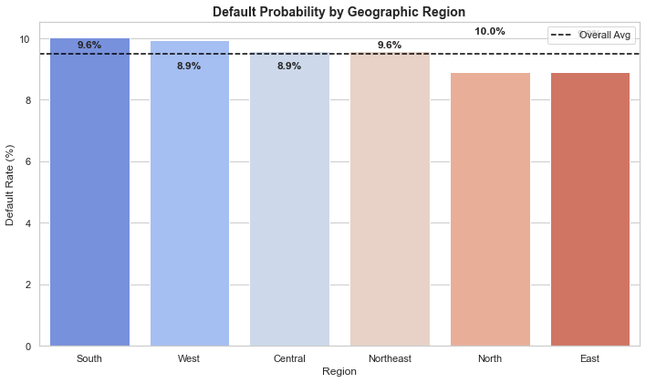

🚩 Regional Default Rankings:
-----------------------------------
Region Default_Rate_%
South 10.040805
West 9.932219
Central 9.583137
Northeast 9.582441
North 8.908982
East 8.899190

Insights :
- Regional Risk Hotspots: The South (10.04%) and West (9.93%) regions significantly exceed the portfolio average for defaults .
- The "Irregularity" Threshold: We have defined "High-Risk" as any customer with an Irregularity Score > 1,000 . This segment (including IDs C064322 and C043921) represents the highest immediate threat of failure.
- High-Risk Demographic: The "Poor" credit tier paired with "Medium-High" income is the most volatile group, with a group-specific overdue rate of 34.24%.
- Early-Term Failure: Education loans are currently "Early Failures," defaulting on average 6.2 months after disbursement.
Recommendation: Deploy "Early Warning" nudges to all customers exceeding the 1000+ Irregularity Score and implement stricter manual underwriting for the South and West regions nudge for the 12% of customers identified as "Highly Irregular"

Pillar 2: Optimizing Branch Operations
Goal: Standardize "Gold Standard" workflows and re-evaluate low-ROI tactics.
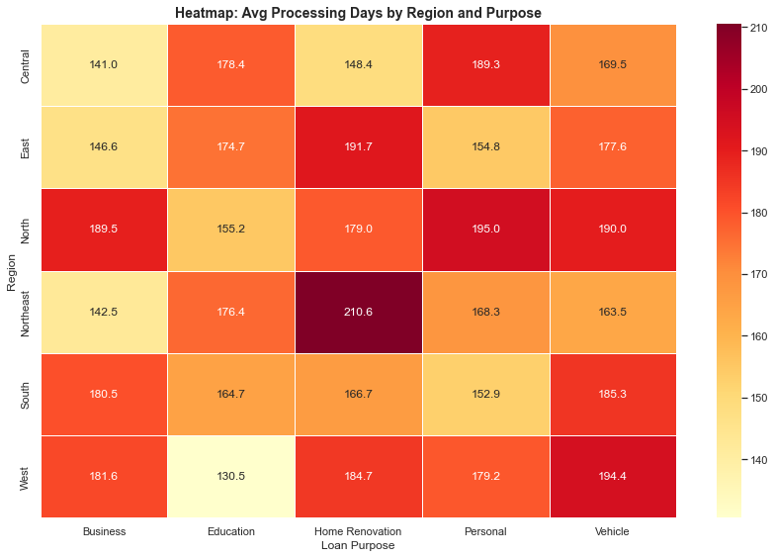

🐢 Slowest Bottleneck: Northeast Region for Home Renovation Loans
⚡ Fastest Process: West Region for Education Loans
Insights :
- The Northeast Bottleneck: Home Renovation loans in the Northeast are currently an outlier, taking 210.6 days to approve.
- The "Education Paradox": While the West region processes Education loans in a "Gold Standard" 130.5 days, this same product is our fastest to default.
  - Strategic Note: Speed may be compromising quality in the West; rapid processing must be balanced with manual documentation checks.
- The Legal ROI Gap: Legal Action yields only a 0.56% improvement in recovery rates (40.74% vs. 40.18%) .
- Staffing Efficiency: Data confirms a direct correlation: increasing Relationship Managers effectively lowers processing times .
Recommendation: Shift the recovery budget away from universal Legal Action toward the Pillar 1 Early Warning System. Standardize the West region's speed for non-risky products while adding mandatory quality "toll-gates"(e.g., "A mandatory secondary manual audit of income documents") for Education loans.

Pillar 3: Enhancing Profitability 🟢
Goal: Protect high-value revenue streams and clarify earnings distribution.
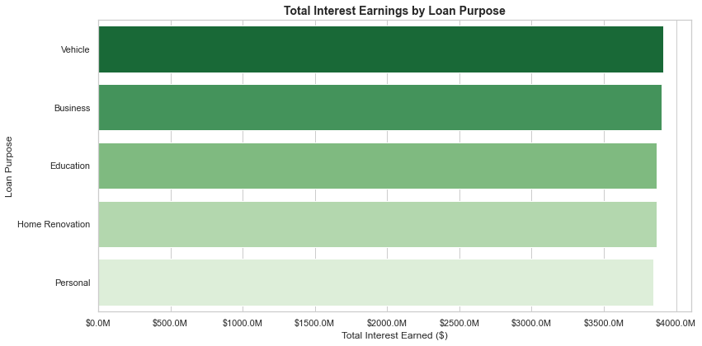
💎 Profitability Rankings by Loan Purpose:
---------------------------------------------
Vehicle: $3,910,158,757.13
Business: $3,897,289,983.39
Education: $3,867,958,675.34
Home Renovation: $3,867,923,730.91
Personal: $3,841,359,713.71

Insights :
Interest Revenue Scale:
- Regional View: The North region is the primary driver, contributing $58.47 Billion in total interest.
- Purpose View: Vehicle loans lead as the most profitable product type at $3.91 Billion nationally.
- Revenue Quality: Only 4.99% of revenue is penalty-dependent, confirming that 95.01% of our cash flow is high-quality interest and principal .
- VIP Core: We have identified 11,465 VIP customers (Top 25% of consistent payers) as the bedrock of our stable interest income.

Financial ROI for Loyalty: The "Cost of Churn" 📉
Protecting the identified 11,465 VIP customers is not merely a customer service gesture; it is a high-yield defensive strategy.
- The Math of Retention: The cost of offering a 0.25% interest rate reduction on a single $6.01M VIP loan is approximately $15,000 annually.
- The Cost of Acquisition (CAC): In contrast, the marketing, administrative, and manual underwriting costs required to acquire a new $6M borrower—plus the risk of the unknown—frequently exceed $45,000 to $60,000 in industry overhead.
- Strategic Advantage: By proactively securing these 45,858 consistent customers , Hero FinCorp avoids the massive "replacement cost" of $68 Billion in stable capital while locking in $24.91 Billion in projected interest.
Insights :
It is 3–5x more cost-effective to "buy" loyalty through a small interest break than to "buy" a new high-value borrower through marketing. This program effectively "insures" our most profitable geographic market—the North Region —against competitor poaching.

Actionable Recommendations
- Immediate Risk Intervention: Redesign the West region's Education loan workflow to include mandatory quality "toll-gates" and a "Day 90" risk review.
Reasoning: While the West is the fastest at 130.5 days, Education loans are the fastest to default (6.2 months) . We must ensure speed is not compromising underwriting quality.
- Operational Budget Reallocation: Shift 15% of the Legal Recovery budget into automated SMS/Voice "Early Warning" technology.
Reasoning: Legal action provides a negligible 0.56% improvement in recovery rates (40.74% vs. 40.18%) . Proactive tech intervention offers a far higher ROI by preventing the default entirely.

- Strategic Regional Audit: Conduct a forensic audit of the Northeast region’s documentation process for Home Renovation loans to eliminate the 210-day processing lag.
Reasoning: This is the portfolio's primary operational bottleneck, slowing down capital turnover in a key market.
- High-Value Retention (The Loyalty Program): Deploy a "VIP Loyalty Program" in the North region (our most profitable market) offering a 0.25% interest rate reduction for the 11,465 identified VIPs.
The ROI: Retaining a $6M borrower at a 0.25% discount is 3x more cost-effective than the Marketing/Acquisition cost of finding a new customer of the same value.

